# I. Description of PCB system

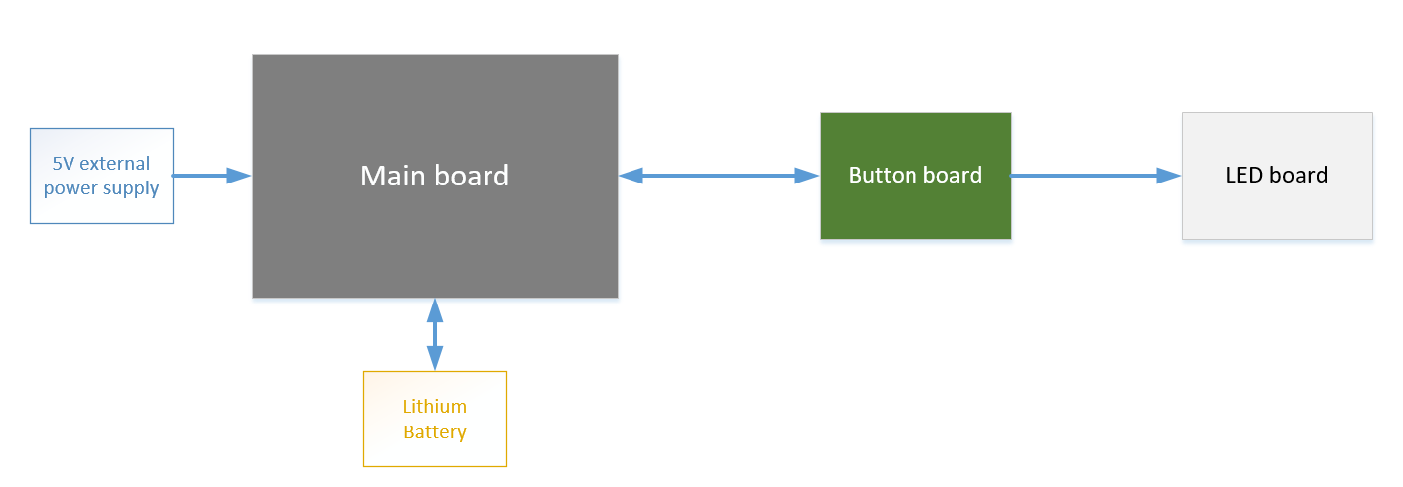

## 1. Main board

Includes:

* Input power supply block, providing power for the entire system. Power supply via USB type C port, and using 4.2V Lithium battery
* Processing block, MCU (RP2040) + SPI Flash for storage
* 3 Flash LED: White, RED, Green, with brightness of about 100-150lumen
* Connector to connect to Button board

## 2. Button Board

Includes:

* 2 buttons to control Flash LED and Constant LED
* 4 green LEDs size 0805, to indicate Battery Level
* Connector to connect to Main board and LED board

## 3. LED board

* Includes 1 White LED

# II. Detailed block diagram

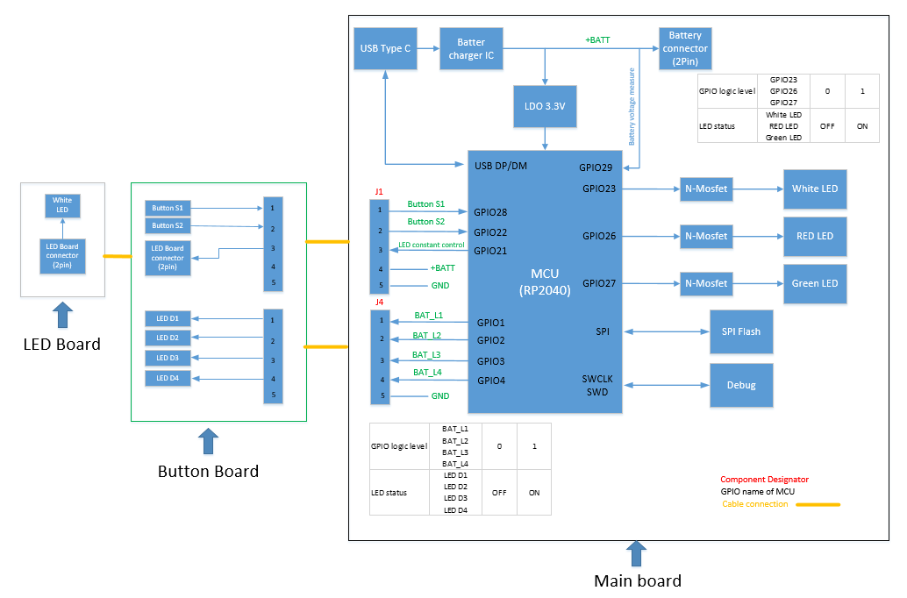

**Preliminary operating scenario:**

**- Button control LED:** When pressing Button S1/ Button S2, it will send a notification signal to MCU -> MCU will know that the button is pressed -> MCU will control the logic level of GPIOs to control Flash LED (3 colors can be controlled separately by 3 GPIOs) and control Constant LED

**- Battery level status:**

+ Battery voltage is input to ADC pin (GPIO29) of MCU to determine the voltage level at that time of Battery

+ Each voltage level of Battery will correspond to Level (Software Engineer will determine it) -> MCU will control the status of LED D1, D2, D3, D4 accordingly

# III. Programing

* Software use: Adruino IDE
* Upload and programing: Via USB type C connector
* Debug: Use SWD for debug